Burns Celebration
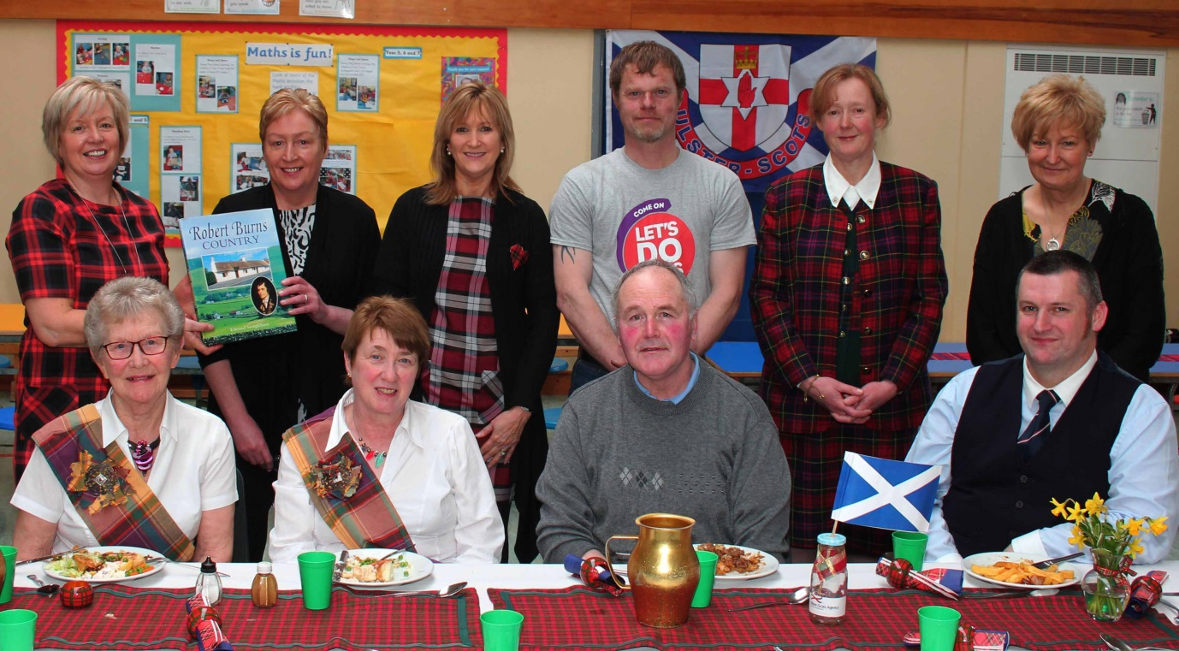
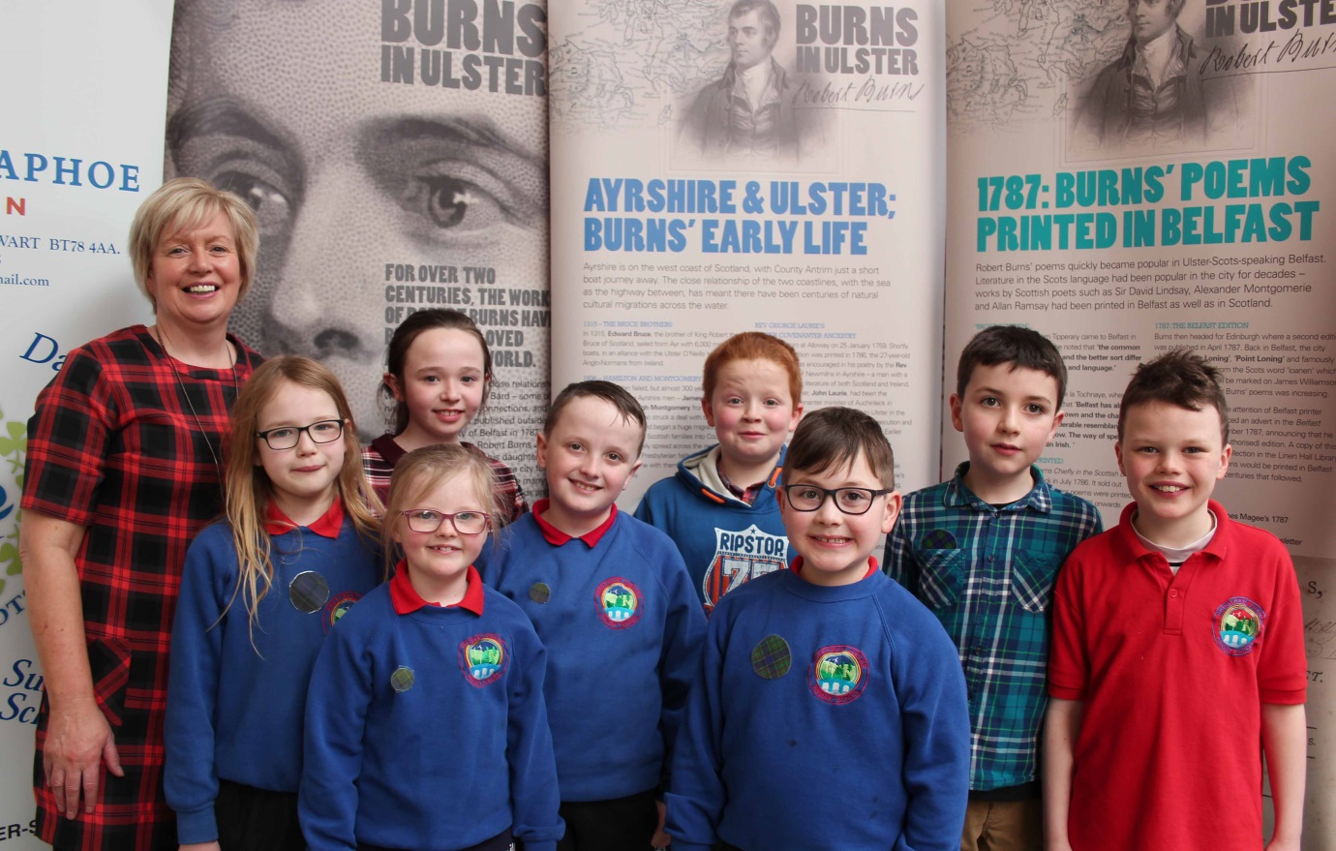
We have been learning a lot about Ulster Scots and recently took part in a Burns Celebration at Newtownstewart Model Primary School.

